**Prototype Mockup for an E-Learning Solution on Plagiarism Avoidance**

### **A. Context**

Section ‘A.’ contains LXD Foundations materials to provide context for plagiarism instructional problem evaluated in a Weaver University case study:

**Task 1 - C1. Learning Objective**

Learners will apply correct APA citation techniques to revise a research paper that contains plagiarism errors, demonstrating mastery of academic integrity skills required for WR001.

**Task 2 - C. Storyboard**

The LxD storyboard uses GitHub Pages, Markdown, and HTML. It is published on the internet [here](https://jm1021.github.io/student/english/plagiarism/storyboard/), but all relevant elements for this assignment are captured within the document in slide-like visuals.

**Task 2 - C1a. Why Plagiarism Matters**

Page 1: Key questions and content; this would likely be personalized by the instructor.

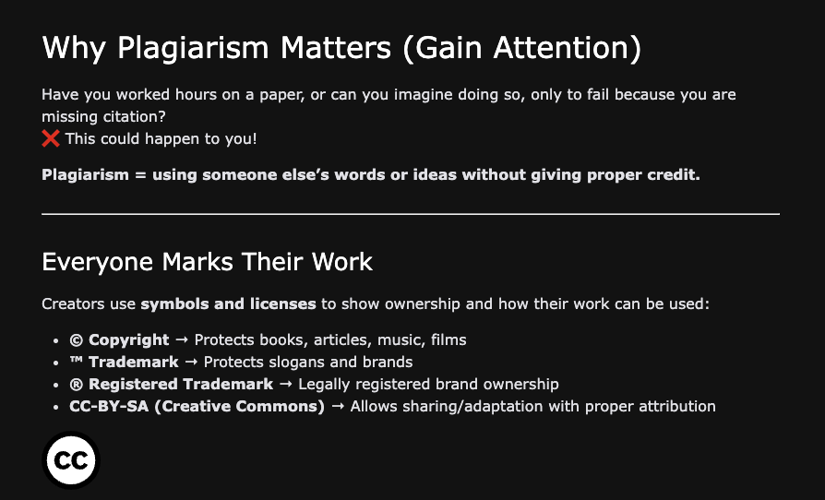

**Task 2 - C1b. Introduction**

Page 2: Insight provided to the learner on the training objectives. This is Merril’s 1st principle with slight modifications to meet objectives of this assignment.

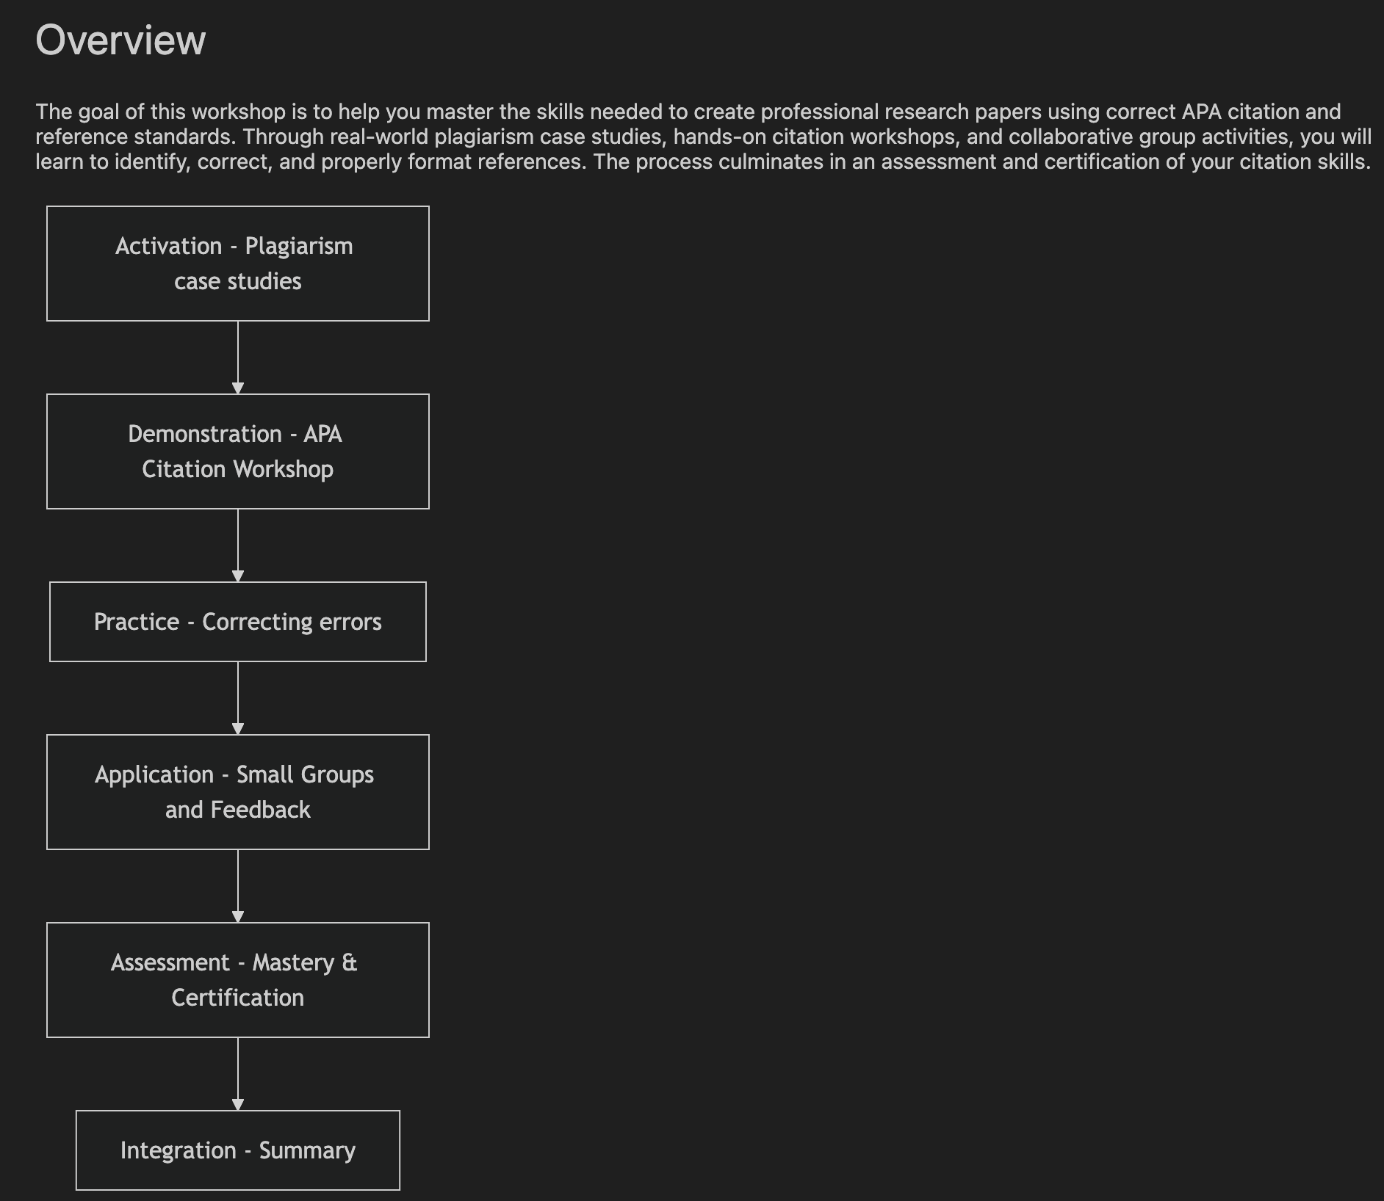

**Task 2 - C2a. The Importance of Plagiarism**

Page 3: Grab learners’ attention with plagiarism cases.

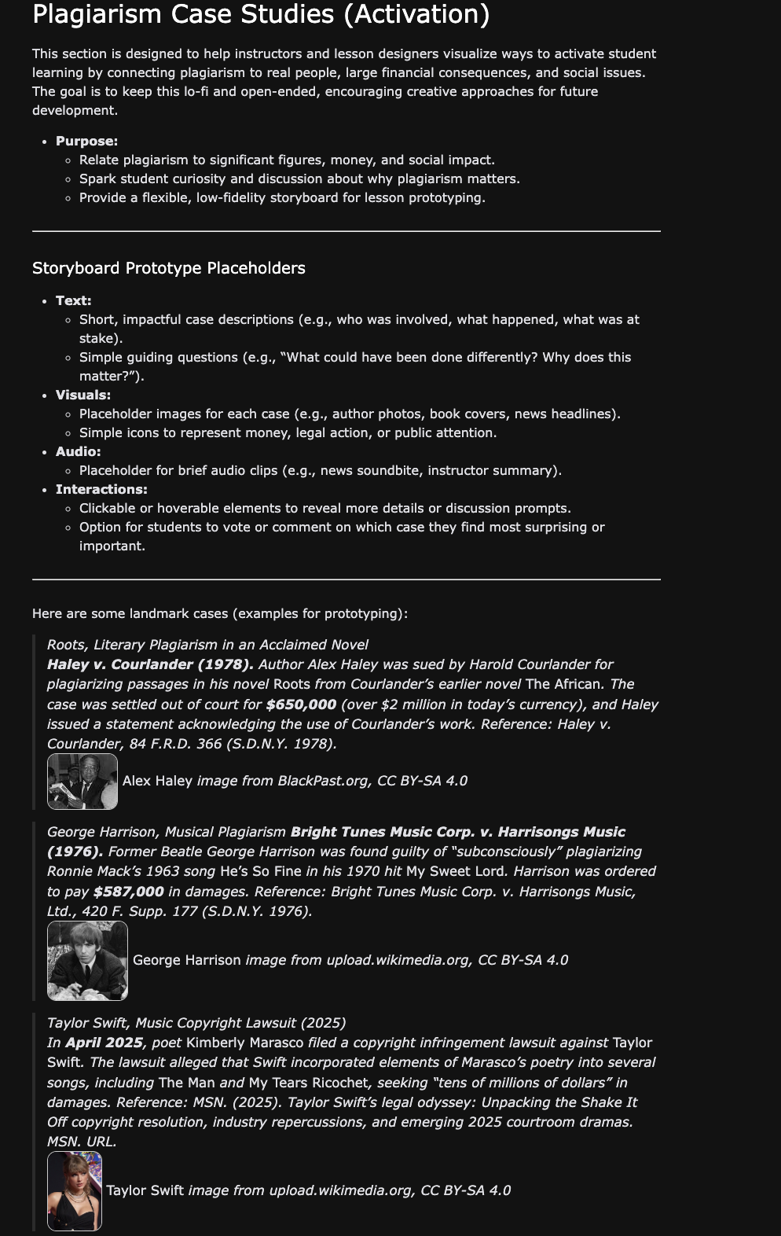

**Task 2 - C2c. Practice correcting errors**

Page 4: This is where the citation learning happens.

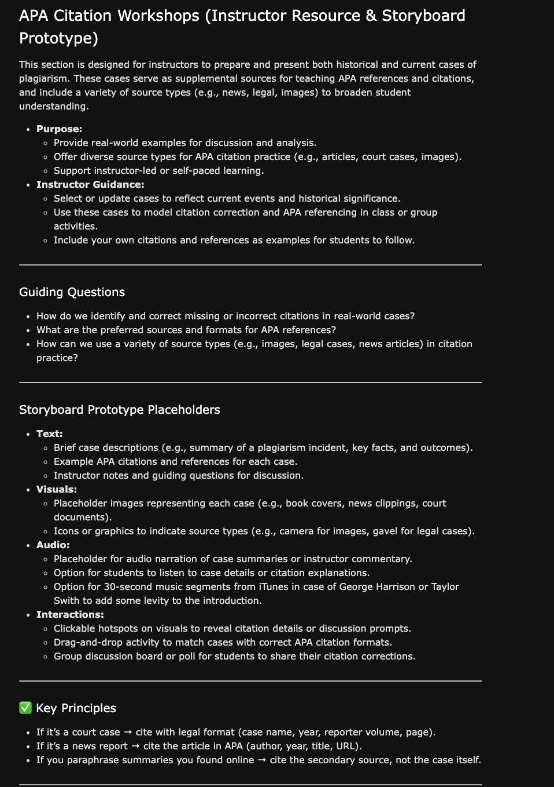

Workshop Tool

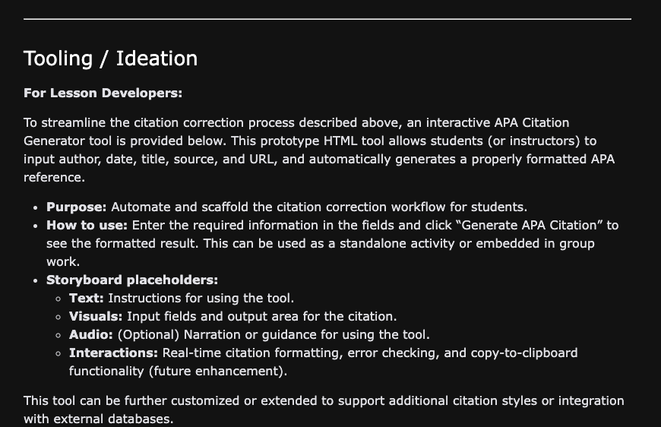

Tool Sample

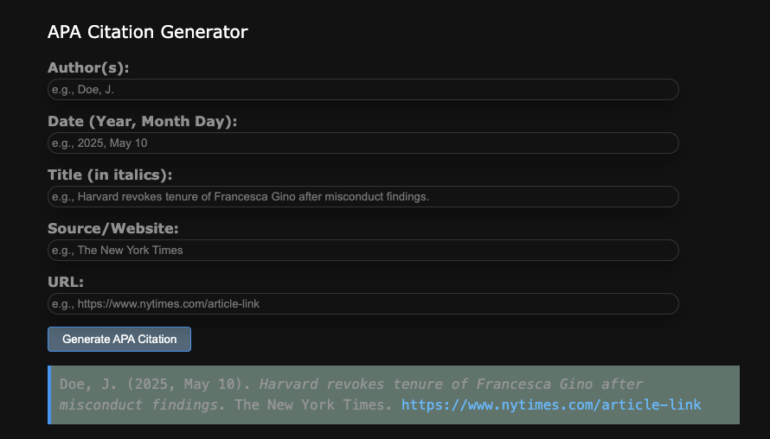

**Task 2 - C2d Group Workshop**

Page 5: Group meeting to correct paper that lacks citations and references.

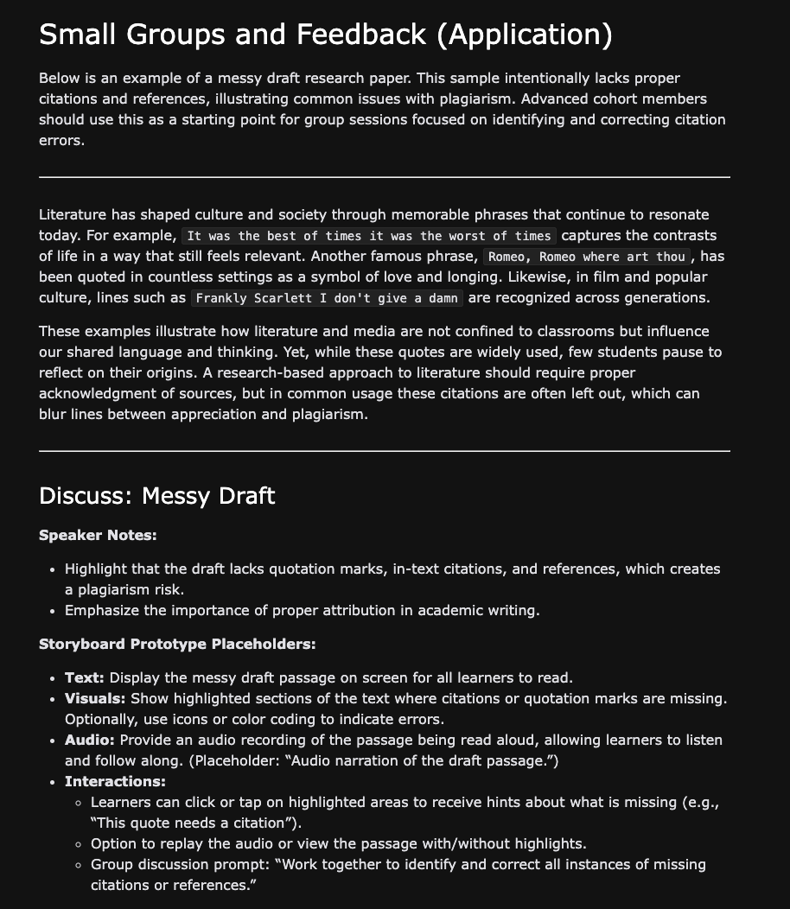

**Task 2 - C3a. Assessment of Workshop**

Page 6: Instructor assessment.

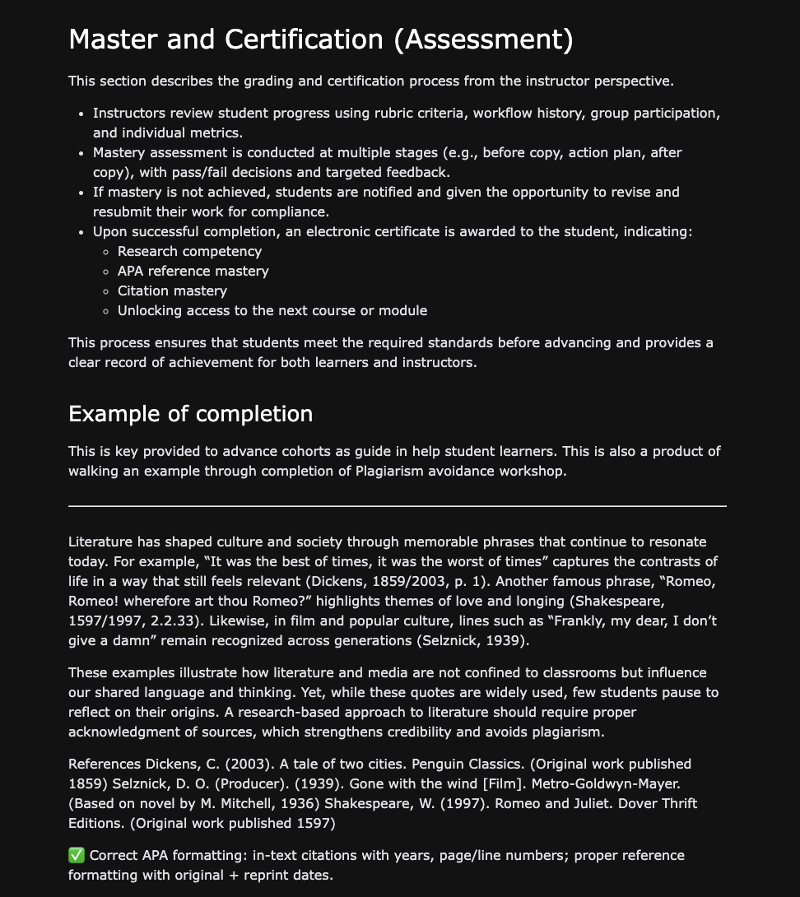

**Task 2 - C3b. Summary**

Page 7: Student learning outcomes.

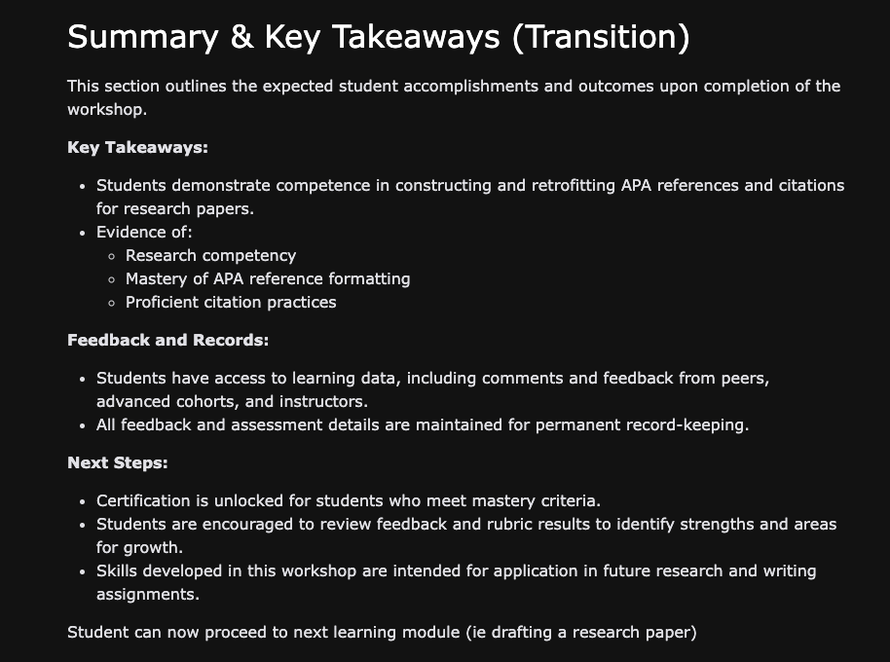

**B. Original E-Learning Training Module**

This plagiarism workshop system is a **sophisticated, multi-module e-learning solution** that far exceeds the basic mockup requirements. Instead of 6-10 screens, I have prototyped a **6-module learning system.**

**This document is intended to cover requirements. However, the system is online and is at:**

[**https://pages.opencodingsociety.com/plagiarism**](https://pages.opencodingsociety.com/plagiarism)

**Generative AI features require a login (user: hop, password: 123Hop!) at:**

[**https://pages.opencodingsociety.com/login**](https://pages.opencodingsociety.com/login)

**Return to link on plagiarism (above) after login.**

* User navigation with progress tracking and introduction
* Cross-module data integration, progression to support tracking
* Plagiarism case studies C1
* Mastery modules C2, C3, C4, each formative, but as whole they are summative
* Assessment Module C5
* Student Mastery Certificate
* Generative AI support in C2 (API citation generator is a must try)
* Generative AI support (Plagiarism detection, Thesis building, 5-paragraph essay, Research paper)
* Instructor assessment tools
* Certificate generation
* UI/UX/LxD design to meet Task 3 requirements
* Contains the Test Mode buttons to support quick module transitions.

**B1a. Navigation and Tracking Page (clipped 2/6)**

The landing page serves as the central navigation point to launch the “Why Source?” Introduction.

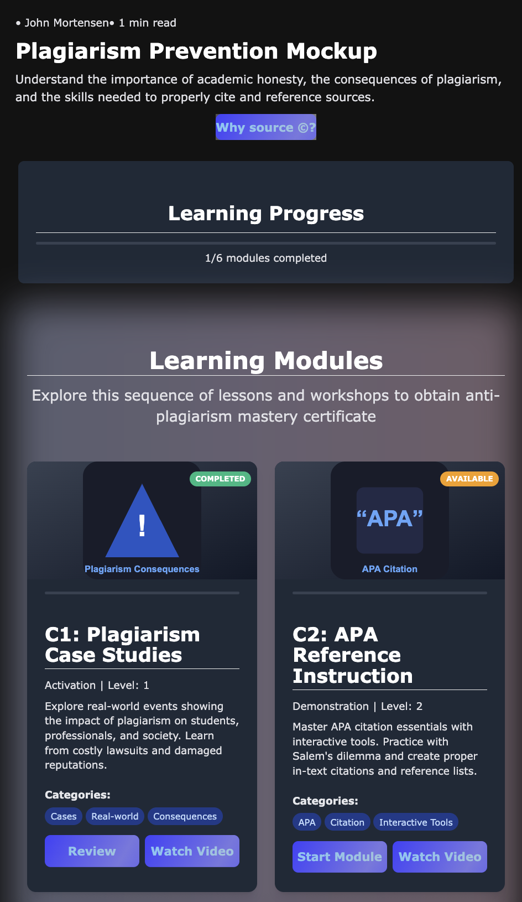

**B2a. Introduction Page (Intro at top, fragment)**

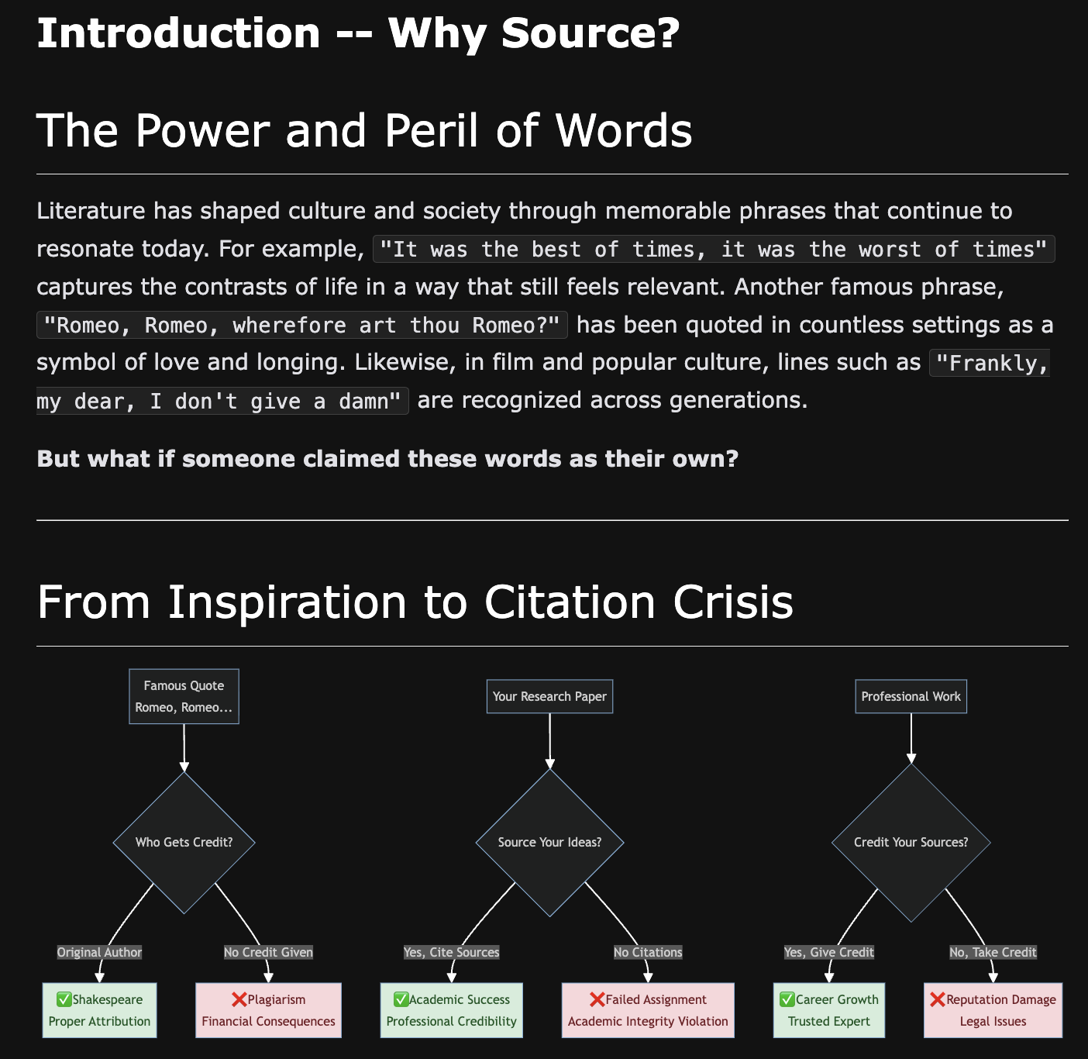

**B2a. Introduction Page (Rubric, fragment)**

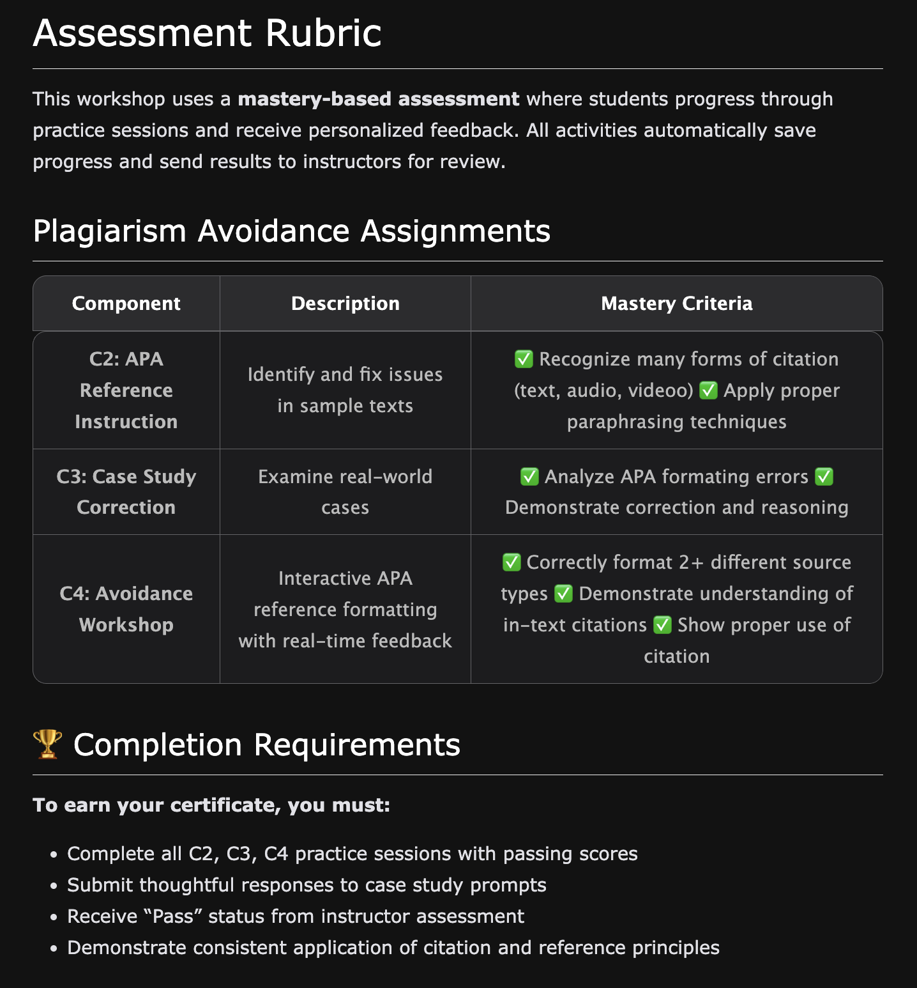

**B. C1 Content – Plagiarism Case Studies (fragment)**

Includes Video and Audio players.

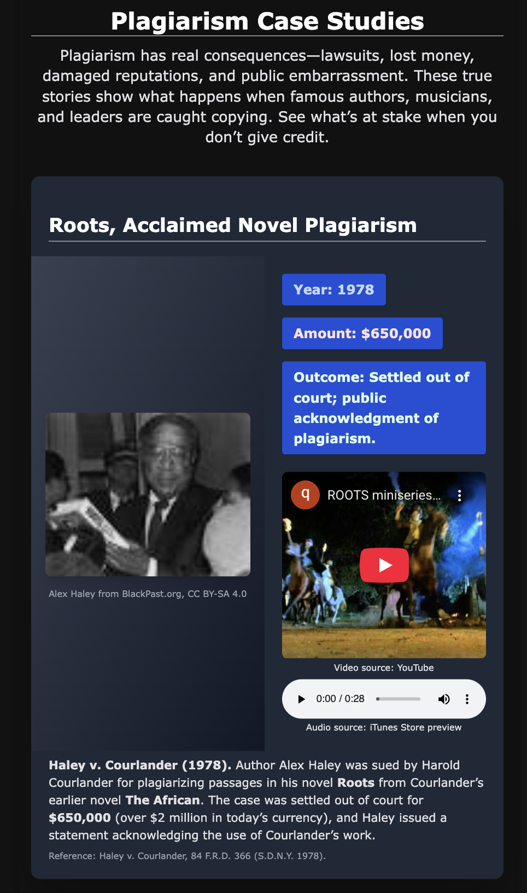

**B. C2 Content – API Reference Instruction (clipped)**

Includes Generative AI and formative assessment data that is passed to C5.

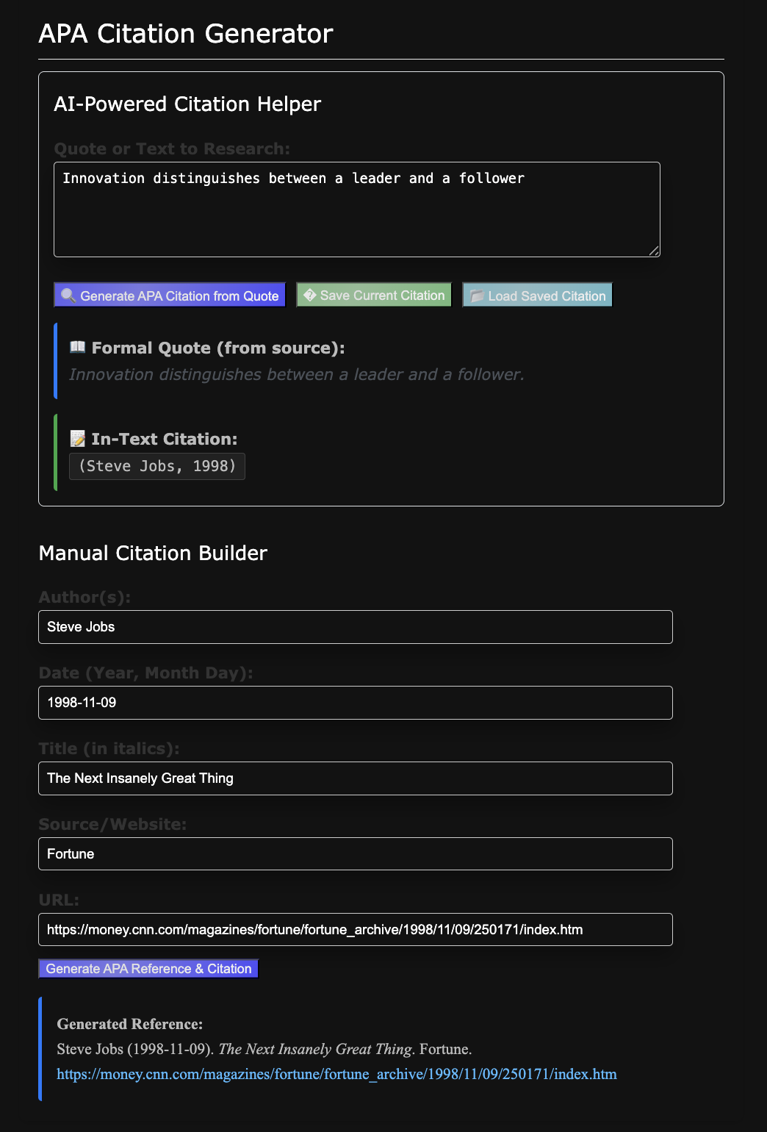

**B. C3 Content – Reference Correction Practice (fragment)**

Includes formative assessment data that is passed to C5.

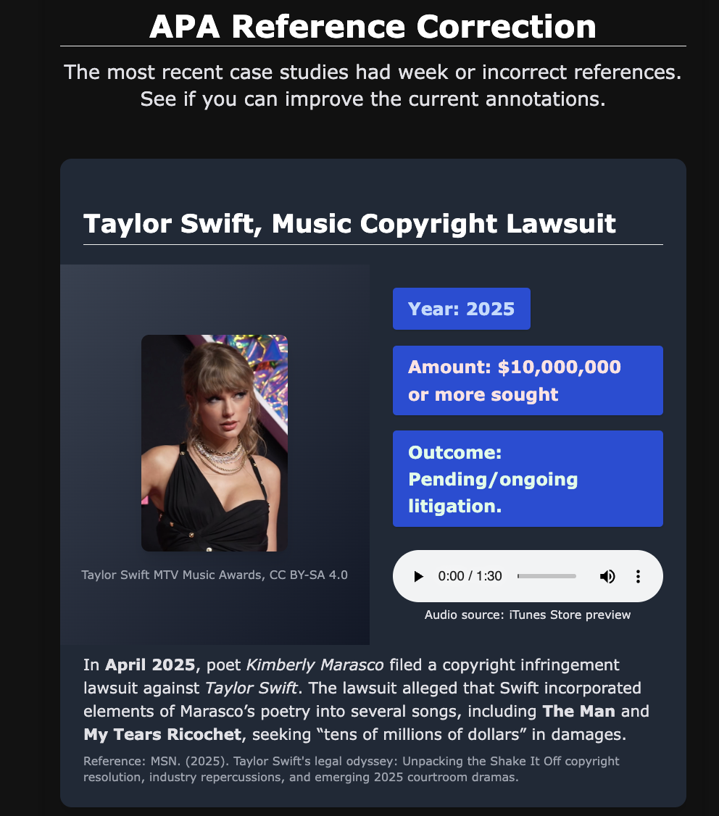

**B. C4 Content – Plagiarism Avoidance Workshop (fragment)**

Includes Generative AI to support plagiarism checks and summative assessment data that is passed to C5.

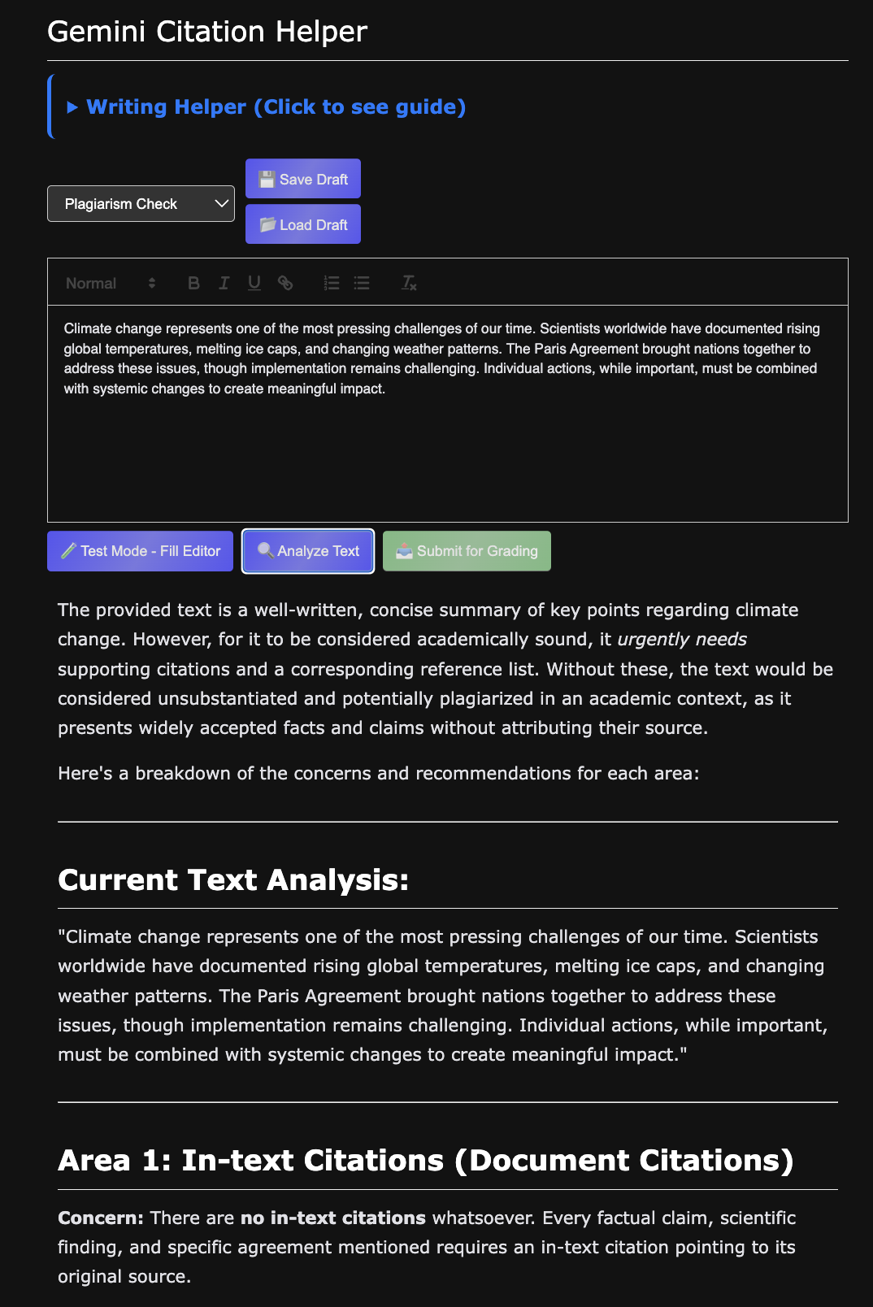

**B. C5-1 Instructor Review (clipped)**

Displays key learning achievements by students from C2, C3, C4. Supports grading and comments.

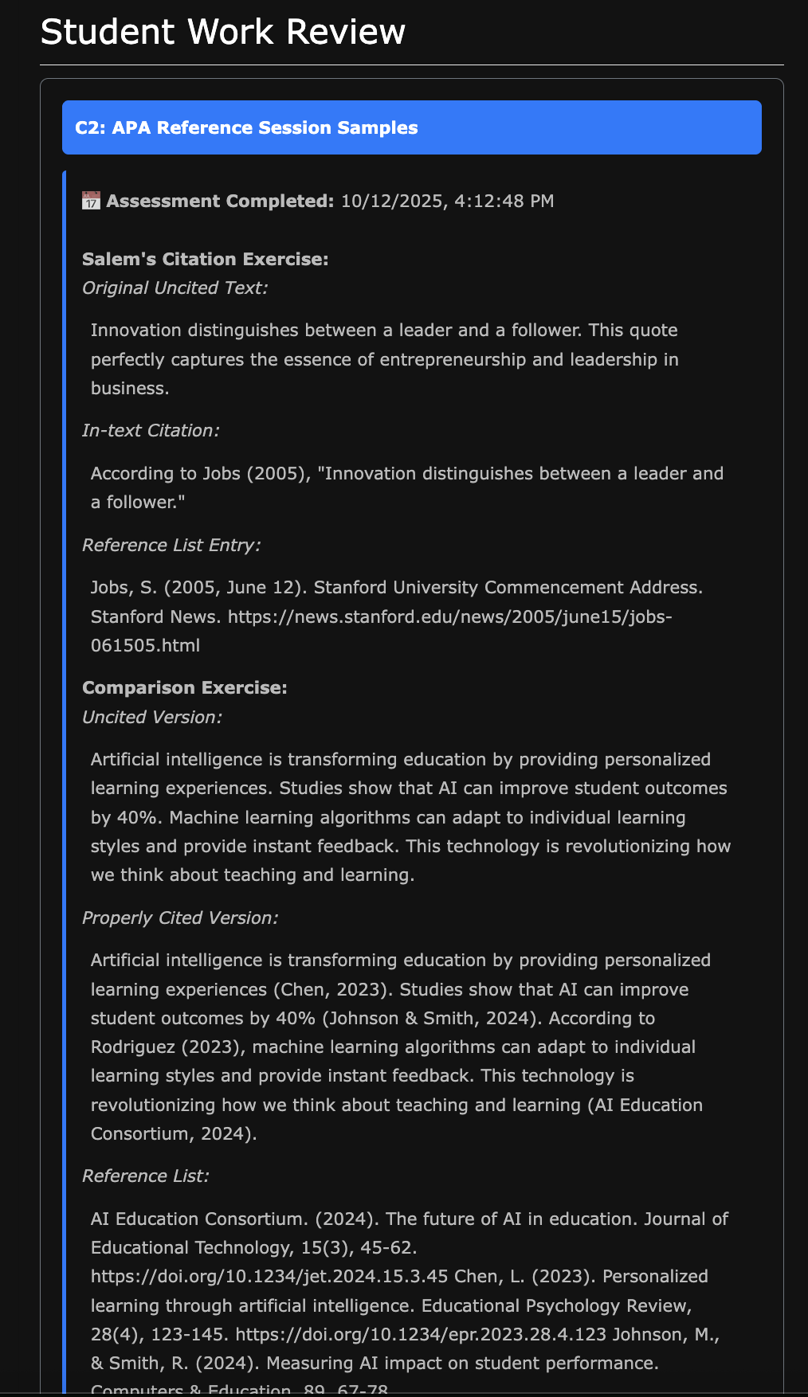

**B. C5-2 Instructor Assessment (fragment)**

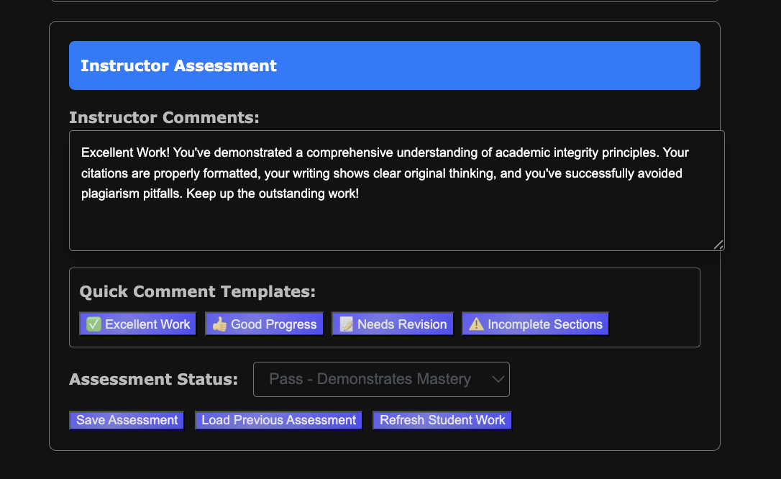

**B. C6-1 Student Master Completed (clipped)**

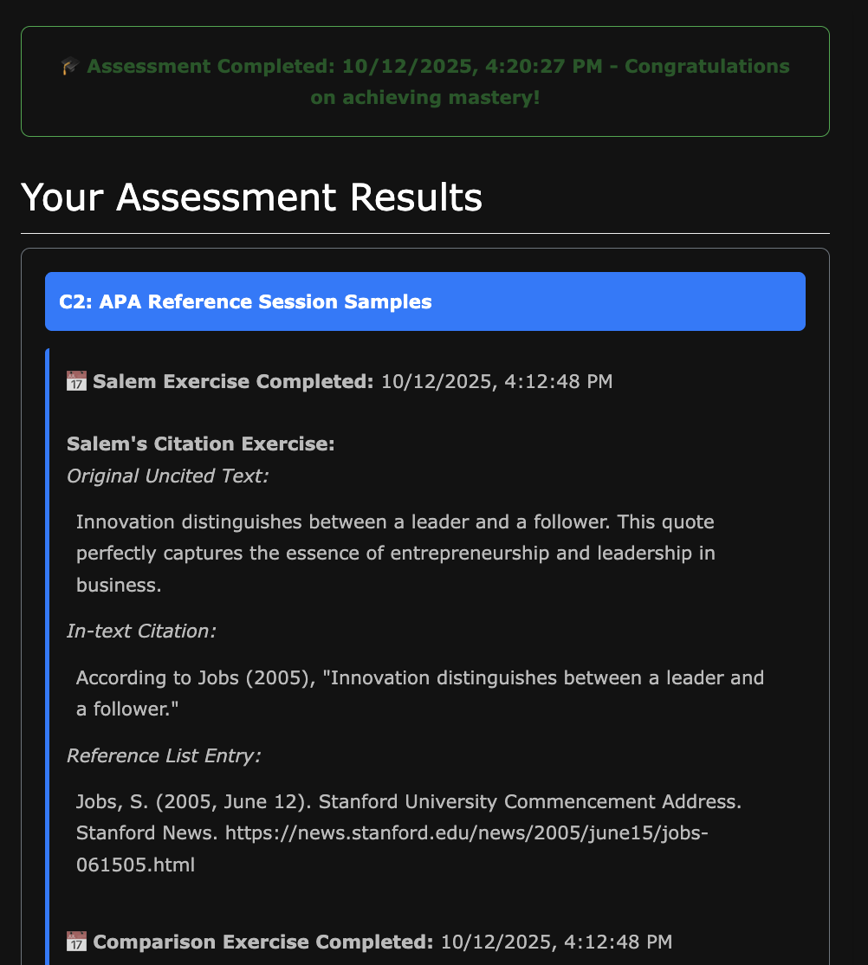

**B. C6-2 Student Master Completed (fragment)**

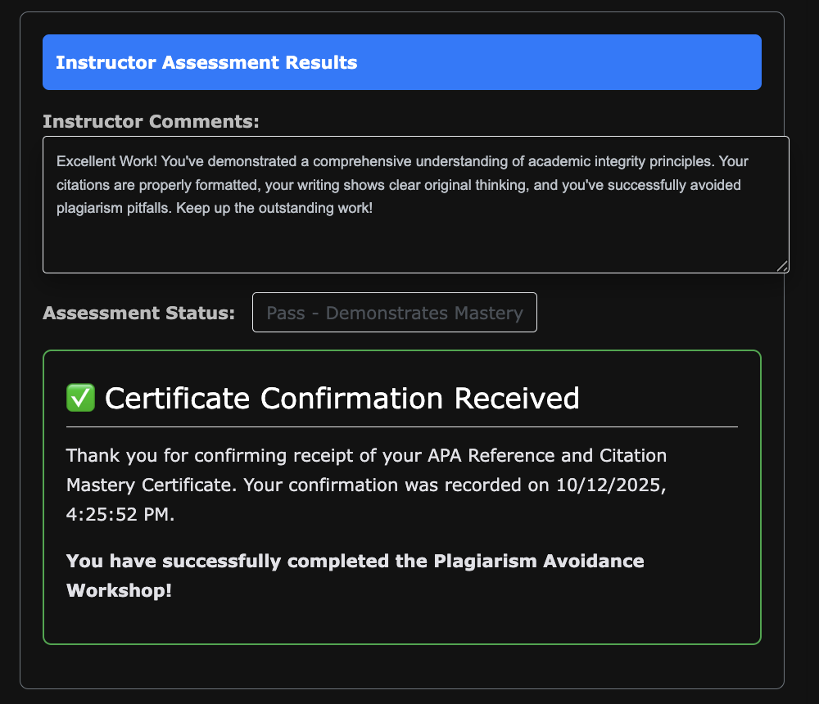

**C. Explain Sensory and Interactive Elements**

Review of learning achievements.

**Visuals and Graphic Design Principles**

* The navigation page provides custom SVG icons for each module
* Progress bar shows progressions
* Status badges (locked/available/completed)
* Card hover effects with shimmer animations

**Interactivity:**

* Click-to-progress module unlocking
* Interactive form submissions with real-time validation
* Auto-loading data between modules
* Quick comment template buttons for instructors
* Frontend/Backend Generative AI API presentations

**Videos:**

* Working link embedded in C1 Plagiarism Cases card
* Video links staged for Navigation elements (TBD)
* Framework ready for audio narration (video links support this)

Audio:

* Audio player integration on C1

**How This Meets Academic Requirements**

**C1. Visual & Graphic Design Principles:**

* White Space: Clean card layouts with proper padding, breathing room between elements
* Visual Hierarchy: Clear typography scales (h2, h3), color-coded status system, logical information flow
* Alignment: Grid-based layout, consistent button alignment, centered progress elements
* Movement: Smooth transitions, hover animations, progress bar fills, card lifting effects

**C2. Usability Best Practices:**

* Effectiveness: Sequential learning path ensures goal achievement
* Efficiency: Auto-loading eliminates manual data entry, quick templates speed instructor feedback
* Engagement: Interactive exercises, visual progress tracking, achievement system
* Error Tolerance: Graceful localStorage fallbacks, clear error messages, retry mechanisms
* Ease of Learning: Intuitive navigation, consistent interface patterns, clear status indicators

**C3. Universal Design for Learning (UDL):**

* **Engagement:** Multiple learning modalities (video, text, interactive exercises), progress gamification
* **Representation:** Text + visual + interactive content, self-pacing through module system
* **Action & Expression:** Multiple assessment formats, instructor feedback options, student choice in completion order

**C4. Accessibility:**

* **Perceivability:** High contrast design, clear typography, meaningful color coding beyond color alone
* **Operability:** Keyboard navigation support, touch-friendly buttons, logical tab order
* **Understandability:** Consistent navigation patterns, clear status messages, predictable interactions

**D. Acknowledgment of Sources**

No sources used outside of WGU-provided materials. Sources used in visuals are self-contained and managed outside of this document.